**Introduction**

The university accounting system is a vital component of the institution's financial operations, serving as a comprehensive platform to manage and monitor financial transactions, payments, and financial agreements. This document presents the Requirements Specification and Analysis (RSA) for the university accounting system, outlining the essential functionalities, user requirements, and security considerations that shape its development.

Purpose of the RSA Document

The primary purpose of this RSA document is to provide a clear and comprehensive understanding of the requirements and specifications that govern the design, development, and deployment of the university accounting system. By documenting these requirements in detail, the document serves as a reference point for developers, stakeholders, and project managers, ensuring that the final system meets the expectations of both users and the university administration.

Significance of Security in Financial Systems

Security is of paramount importance in the context of financial systems, and the university accounting system is no exception. Financial data, transactions, and sensitive student information must be safeguarded from unauthorized access, manipulation, and breaches. Ensuring a robust security framework is essential to maintain the integrity, confidentiality, and availability of financial data and to prevent fraudulent activities that could have serious consequences for the university and its stakeholders.

In this RSA document, we address security considerations alongside functional requirements to create a system that not only streamlines financial processes but also guarantees the highest level of data protection.

By addressing user requirements, functional specifications, and security concerns, this RSA document lays the foundation for a resilient and efficient university accounting system that meets the evolving needs of the institution while upholding the principles of security and transparency.

**Scope and Objectives**

Scope of the Accounting System:

The scope of the university accounting system encompasses a comprehensive range of functions and modules designed to facilitate efficient financial management within the institution. The system will cover the following major functions and modules:

1. Student Financial Management:

   - Managing student payments, tuition fees, fines, and refunds.

   - Enabling students to set up financial agreements for structured payment plans.

   - Processing application forms for financial statements and other financial matters.

2. Supplier and Payment Management:

   - Handling supplier interactions, purchase orders, and invoices.

   - Recording payments made to suppliers for goods and services.

3. Income and Expense Tracking:

   - Recording income transactions such as tuition fees, grants, and donations.

   - Tracking expenses for salaries, utilities, supplies, and other expenditures.

4. Financial Reporting and Analysis:

   - Generating financial reports, including income statements and balance sheets.

   - Providing insights into the institution's financial health and performance.

5. Security and Compliance:

   - Implementing robust security measures to protect sensitive financial data.

   - Ensuring compliance with data privacy regulations and industry standards.

**Objectives of the RSA Document:**

The objectives of this RSA document are as follows:

1. Clear Documentation of Requirements:

   - Clearly define the functional requirements of the university accounting system.

   - Document the technical specifications needed to implement the system's features.

2. Alignment with Security Goals:

   - Ensure that the design and development of the system prioritize data security.

   - Address authentication, authorization, data encryption, and access controls.

3. Data Confidentiality, Integrity, and Availability:

   - Guarantee the confidentiality of sensitive financial data, preventing unauthorized access.

   - Maintain data integrity to ensure accuracy and reliability in financial transactions.

   - Ensure the availability of the system for users whenever needed.

4. Efficient Financial Processes:

   - Streamline financial processes, enabling students, staff, and administrators to perform transactions smoothly.

   - Provide automated features for payments, agreements, and reporting.

5. Scalability and Adaptability:

   - Design the system with scalability to accommodate future growth and evolving requirements.

   - Ensure that the system is adaptable to changes in financial policies and regulations.

6. User-Centric Design:

   - Create a user-friendly interface that is intuitive for staff, students, and administrators to use.

   - Enhance user experience by providing clear workflows and instructions.

7. Stakeholder Collaboration:

   - Facilitate effective communication between stakeholders, developers, and project managers.

   - Enable stakeholders to review and provide feedback on the system's features and functionalities.

**Static information from the university**

**Scholarships:**

1. **Baccalaureate Scholarship:**

Based on high averages in official Lebanese BACC II degree exams.

Discount Rates:

14 – 14.99: 10%

15 – 15.99: 20%

16 – 17.99: 30%

18 and above: 100%

Continuity Conditions: Maintain a certain CGPA in consecutive semesters.

1. **Scholarships for Academic Excellence:**

Outstanding students with high CGPA who completed at least 15 credits.

Discount Rates:

3.50 – 3.74: 20%

3.75 – 4: 30%

1. **Social Scholarships:**

50% scholarships for orphans under 21 years old.

Discount rates based on limited financial capacity, ranging from 5% to 45%.

1. **Special Scholarships:**

40% scholarship for graduates, employees of Al Mabarrat Association institution, and their children.

Educational scholarships for institutions with agreements.

1. **Student Support Fund Scholarship:**

Provides study fee coverage through soft loans for indigent students.

Loan repayment terms are determined based on graduation and employment.

1. **TOMOOH Scholarship:**

Students facing difficult economic circumstances with a minimum average of 12/20 in the final three years of secondary education.

Offers scholarships from 50% to 100% based on social and academic factors.

Continuation Conditions: Maintain CGPA, adhere to student code of conduct, and complete graduation requirements in three years.

<https://www.usal.edu.lb/admissions/scholarships-and-financial-aid/>

### **Tuition FEES:**

* Tuition Fee - BS in Computer Science (Per Credit): $25 + 750,000 L.L per credit
* Tuition Fee - BS in Business, Media, and Education (Per Credit): $20 + 630,000 L.L
* Tuition Fee - TD (Per Credit): $30 + 1,120,000 L.L per credit
* Registration Fee for Fall and Spring Semesters: $150
* Registration Fee for Summer Semester: $100
* Registration Application Fee and Entrance Examination Fees: $50
* NSSF: 4,000,000 L.L

**ACCOUNTING:**

Overview:

* The Accounting Office executes the University's financial policies accurately and with integrity, ensuring compliance with relevant laws.
* The office provides financial reports for decision-making by higher administrations and departments.
* The Cashier handles student-related financial matters and the University's payments and purchases.

Policies:

* Students should know the financial implications of their chosen procedures and abide by the University's financial regulations.
* Application fees, placement test fees, and registration fees are non-refundable.
* Students face a penalty fee if they fail to register within the designated period.
* Withdrawal in the second or third week of a semester requires payment of 30% of the course's credit cost.
* Withdrawal after the third week necessitates full payment of the course's credit cost.
* Tuition fees should be paid as scheduled in the University Calendar. Failing that, a fine is incurred if no prior financial agreement was made.
* Tuitions are paid in cash and in Lebanese Lira based on the official exchange rate.
* Tuition payments are divided into four installments within specific periods.
* First Payment: Within two weeks from the semester's start
* Second Payment: Within six weeks from the semester's start
* Third Payment: Within ten weeks from the semester's start
* Fourth Payment: Within fourteen weeks from the semester's start

Application for Financial Statement:

* Students need to fill an application form at the Cashier to obtain a financial statement.
* If required for an official body, an attached application form is necessary.
* First-time applicants during a semester do not need to pay any fees.
* A financial statement can be obtained after full tuition and fee payment.

Contact Information:

Students can reach the Accounting Office or Cashier through:

* Visiting during working hours
* Calling specified phone numbers
* Sending an email to the provided addres

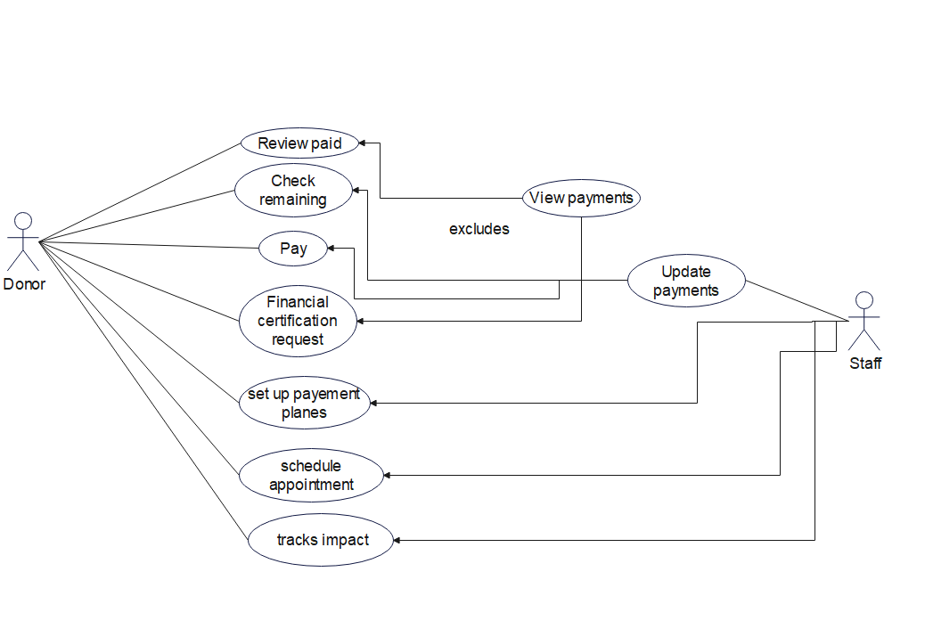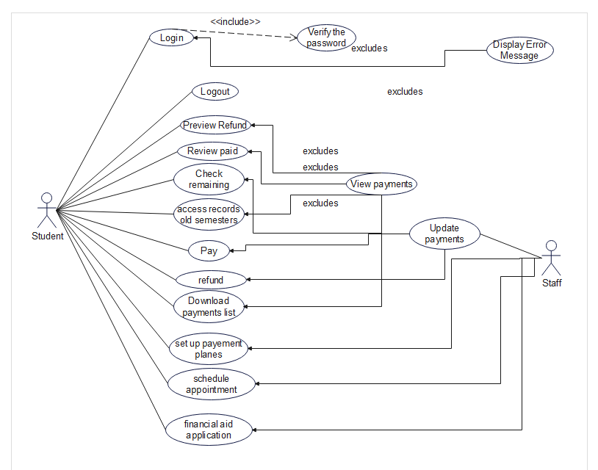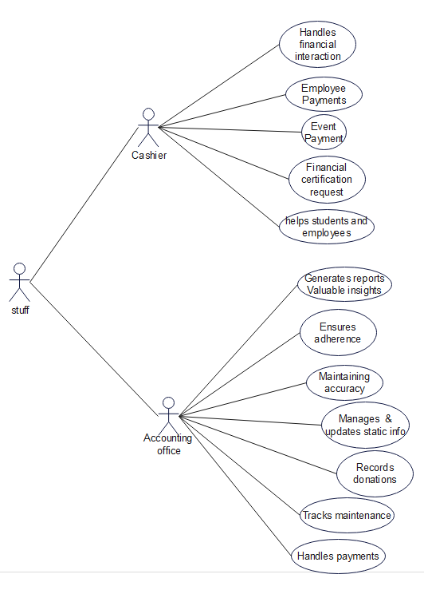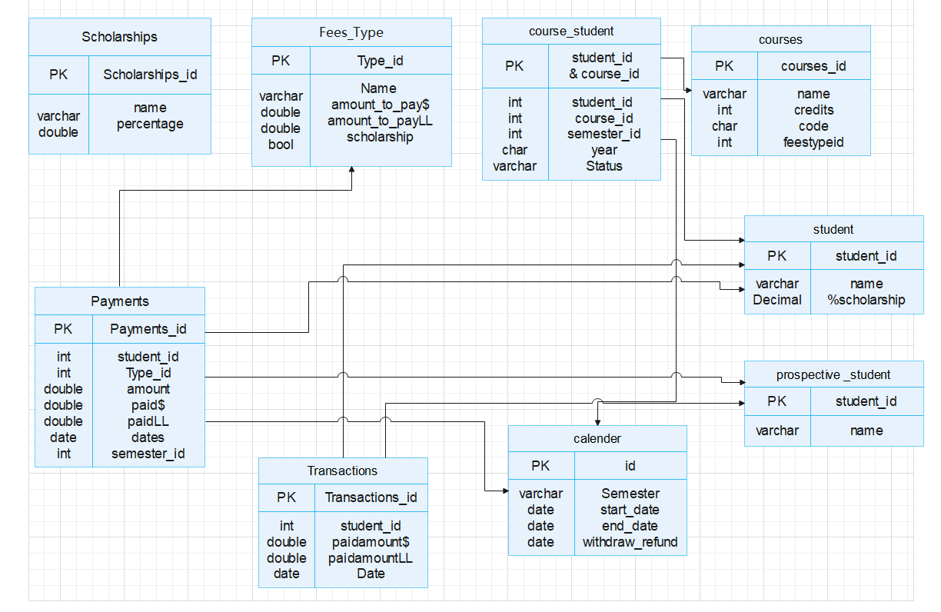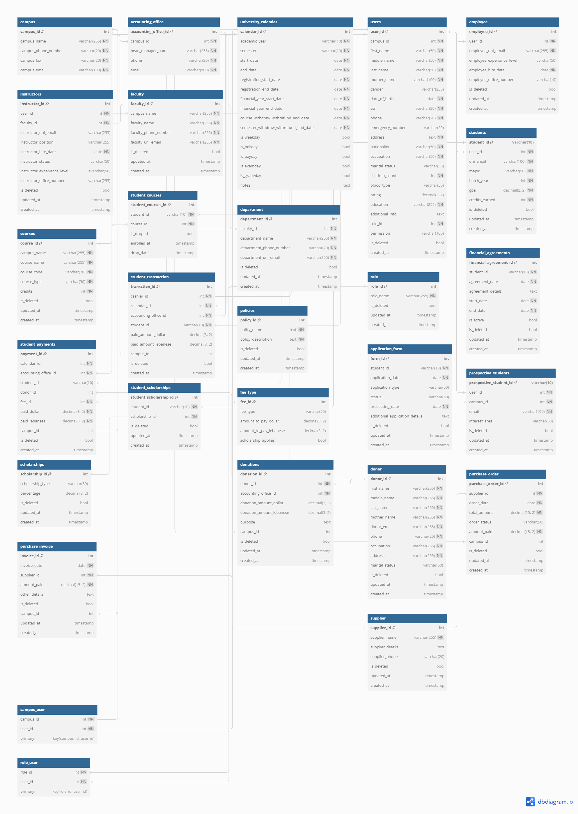

REQUIREMENTS STUDENTS-STAFF:

* Implement a login verification process to enhance the security of student payments.
* Display clear error messages to guide users effectively when issues arise.
* Enable users to securely log out from their accounts, ensuring their privacy and data protection.
* Access a dedicated section to view your payment history and transaction details conveniently like the following:

1. Show potential refunds for transactions

2. Review payments that have been successfully processed

3. Check the remaining balance on your account.

1. Access records from previous semesters for your reference.

* Allow staff to efficiently update payment records when students make payments or request refunds, ensuring accurate and up-to-date financial information.
* Students can conveniently make payments for various services and fees, ensuring a streamlined and hassle-free transaction process.
* Initiating a refund process for students who have dropped out of courses or withdrew from a semester, ensuring fair reimbursement of fees associated with deleted courses.
* Easily request a comprehensive financial statement that outlines your transactions, expenses, and payments, providing a clear overview of your financial activity.
* Easily download a comprehensive payment list, providing you with a convenient and organized record of all financial transactions and payments made.
* Students can schedule an appointment with the accounting department to discuss financial matters or concerns.
* student initiates the process of applying for financial aid to seek assistance with covering educational expenses and the staff evaluates and decides whether to accept or reject the applications for financial aid based on the provided information and eligibility criteria.
* financial statement VS download payments :
* The financial statement is paid version which is detailed and includes comprehensive information and insights compared to the standard version which is download payments

REQUIREMENTS DONOR-STAFF:

* Donors have the ability to review the payments they have made
* Verify the remaining balance to keep track of the funds available for future expenses or transactions.
* Initiate a payment for fees, services, or other financial obligations using one of the provided payment methods.
* Submit a request for financial certification to obtain an official document verifying your financial status or ability to meet certain financial requirements.
* Collaborate with staff to establish customized payment plans, allowing for more flexible and manageable installment-based payments.
* Arrange a specific date and time for an appointment to discuss a particular matter or seek assistance.
* Monitor and assess the effects and outcomes of donations, gauging how they contribute to the intended goals and initiatives.

Cashier:

* Handles financial interactions with students, managing payment collection, fee processing, and issuing receipts.
* Handles the process of paying salaries to university employees, making sure payments are correct and delivered on time.
* Administers event-related financial activities, including registration fees and participant payments.
* Manages various financial transactions, such as handling reimbursements, petty cash, and small expenses.
* Serves as a go-to person for internal financial questions, helping students and employees with their inquiries and providing support on financial matters within the university.

Accounting Office:

* Ensures adherence to the university's financial policies and regulations, maintaining accuracy and integrity in financial operations.
* Manages and updates static financial information, such as price lists and fee structures, to reflect accurate financial details.
* Oversees event payment processes, tracking incoming event-related funds and maintaining accurate records.
* Records payments received from external sources, including donors and partners, and ensures proper categorization.
* Monitors expenses related to facility maintenance, repairs, and services, maintaining clear records of financial transactions.
* Handles payments to vendors and service providers, verifying invoices and maintaining vendor relationships.
* Generates comprehensive financial reports and analyses, providing valuable insights for decision-making and planning.

Non-Functional Requirements:

**Security and Privacy:**

Authentication and Authorization:

* User authentication must follow industry best practices, such as password hashing and salting.
* Role-based access control should be implemented to ensure that users have appropriate permissions.

Data Privacy:

* Personal and financial data of users must be encrypted both during transmission and storage.
* Compliance with relevant data protection regulations (e.g., GDPR, HIPAA) is mandatory.

**Usability and User Experience:**

User-Friendly Interface:

* The user interface should be intuitive and easy to navigate for all user roles.
* Clear and concise language should be used for error messages and instructions.

Responsive Design:

* The system's interface should be responsive and compatible with various devices and screen sizes.

**Performance and Scalability:**

Response Time:

* The system should provide fast response times for all user interactions, aiming for less than 2 seconds per action.

Scalability:

* The system architecture should be designed to handle increased user loads during peak times, such as enrollment periods.

**Reliability and Availability:**

System Uptime:

* The system should have at least 99.9% uptime, ensuring minimal downtime for maintenance or updates.

Backup and Recovery:

* Regular automated backups of the database and system configurations should be performed to facilitate data recovery in case of failures.

**Maintainability and Extensibility:**

Code Maintainability:

* Codebase should follow coding standards and best practices to ensure ease of maintenance by the development team.

Modularity:

* The system's architecture should be modular, allowing for easy integration of new features or components.

**Compliance and Regulations:**

Financial Regulations:

* The system must comply with relevant financial regulations and standards applicable to payment processing and financial reporting.

Accessibility:

* The user interface should be designed to meet accessibility standards (e.g., WCAG) to accommodate users with disabilities.

**Performance Testing and Load Handling:**

Load Testing:

* Regular load testing should be conducted to assess the system's performance under different user loads.

Scalability Testing:

* Test the system's ability to scale and handle increasing loads without compromising performance.

**Documentation and Training:**

User Documentation:

* Provide comprehensive user manuals and documentation for each user role to ensure efficient system usage.

Training:

* Offer training sessions for users and staff to familiarize them with the system's features and functionality.

**Integration and Interoperability:**

APIs and Integrations:

* If applicable, provide well-documented APIs to facilitate integration with other university systems.

Browser Compatibility:

* Ensure the system functions correctly across popular web browsers and versions.

**Reporting and Analytics:**

Reporting Performance:

* The generation of financial reports and analytics should be completed within a reasonable time frame.

Data Accuracy:

* Reports and analytics should reflect accurate and up-to-date financial information.